1.Tool -> Generate Memory Configuration File
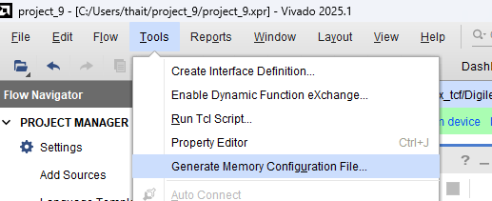

- Gen bin file
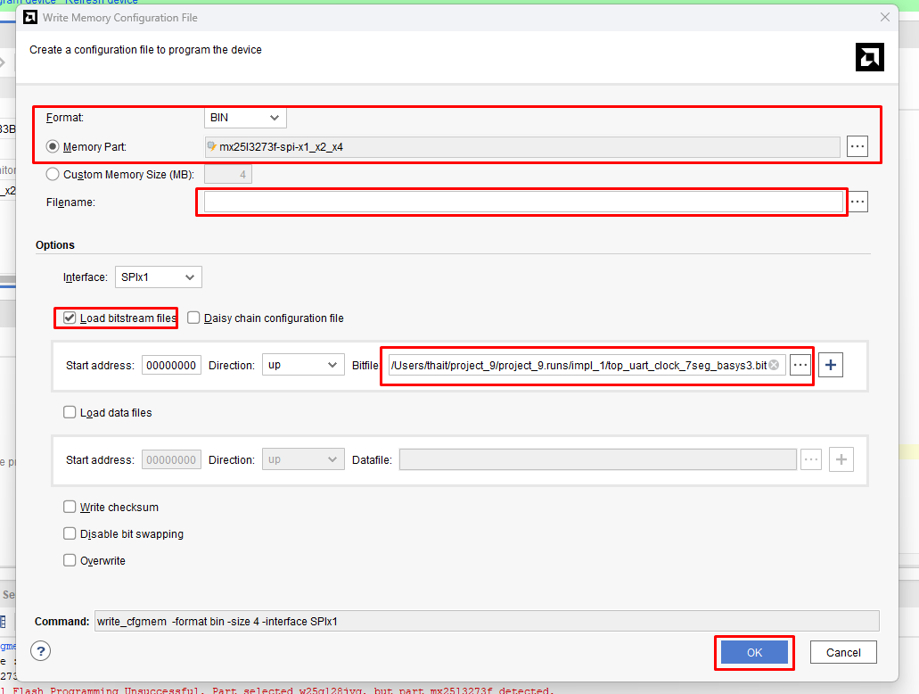

- Open Hardware Manager to connect FPGA
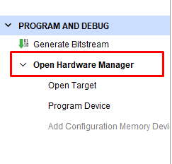

- Add Configuration Memory Device

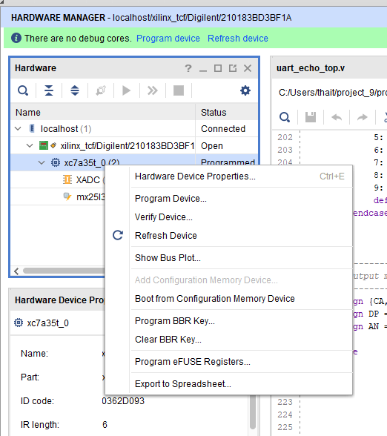

5.
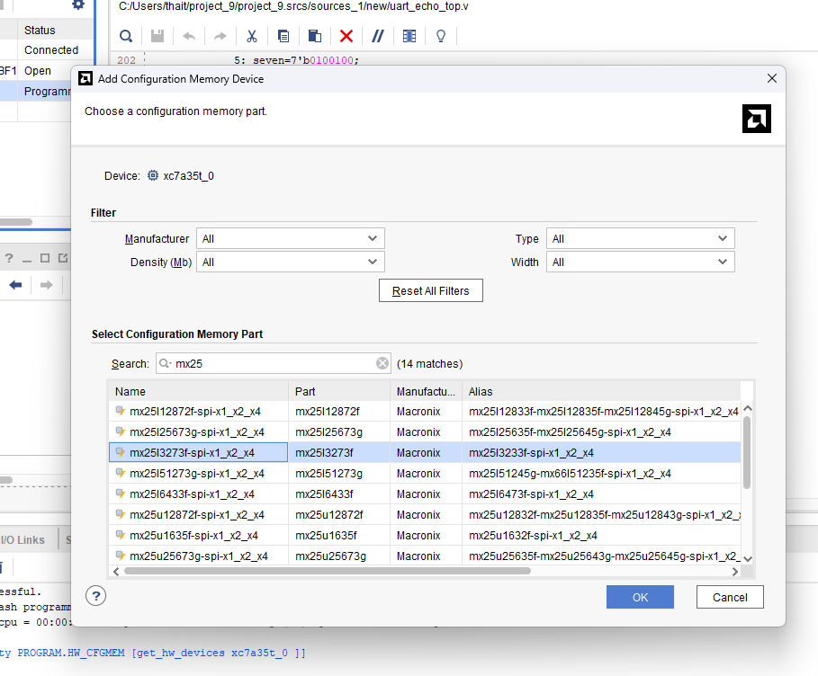

6.

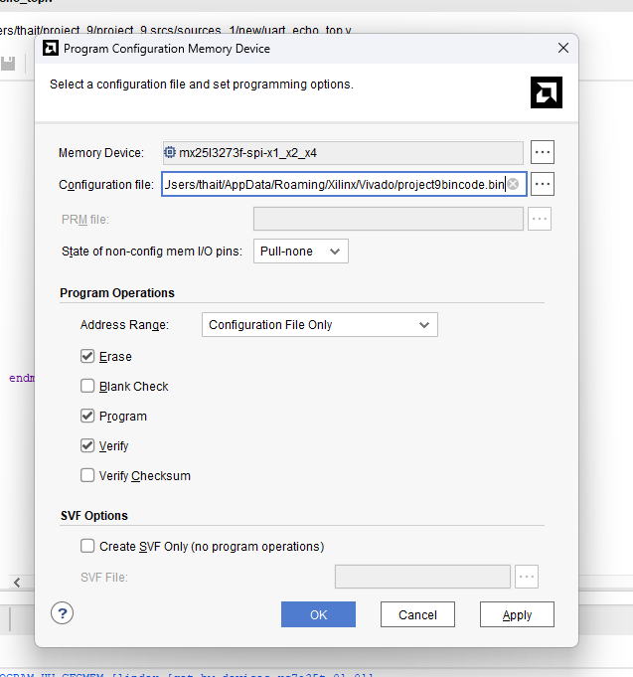

Click OK

- Chọn JTAG mode trên Basys3 ở nút reset

